## **SAP - APPROVAL WORKFLOW**

**Menu**

1. **Masters:**

* Company Master
  + Data Addition without Error. - Test Pass
  + Edit the record without Error. - Test Pass
  + Company code(Unique) **duplicate** should not allow - Test Pass
  + Company code Should **not be Edited**. - Test Pass
  + Company Name, Company Logo and Active Status are **Editable** - Test Pass
  + Active / In-active can be enable while edit. - Test Pass
  + Access to be **Admin User Only.** - Test Pass

* Business Decision Master
* Data Addition without Error. -Test Pass
* Edit the record without Error. - Test Pass
* Business Decision code(Unique) **duplicate** should not allow -Test Pass
* Company code and Business Decision code Should **not be Edited**. -Test Pass
* Business Decision Address and Active Status are **Editable** - Test Pass
* Active / In-active can be enable while edit.
* Access to be **Admin User Only**. - Test Pass
* Plant Master
* Data Addition without Error. -Test Pass
* Edit the record without Error. - Test Pass
* Plant code(Unique) **duplicate** should not allow -Test Pass
* Company code and Plant code Should **not be Edited**. -Test Pass
* Plant Name, Short Name and Active Status are **Editable** - Test Pass
* Access to be **Admin User Only**. - Test Pass
* Department Master
* Data Addition without Error. -Test Pass
* Edit the record without Error. - Test Pass
* Department Code(Unique) **duplicate** should not allow -Test Pass
* Department Code Should **not be Edited**. -Test Pass
* Department code 3 digits - Test Fail
* Department Name and Active Status are **Editable** - Test Pass
* Access to be **Admin User Only**. - Test Pass
* User Master
* Data Addition without Error. -Test Pass
* Edit the record without Error. - Test Pass
* Employee ID(Unique) **duplicate** should not allow -Test Pass
* Plant Code, Employee ID, Should **not be Edited**. -Test Pass
* Role, Email, User Name, User Level, Password, Department and Active Status are **Editable** - Test Pass
* Access to be **Admin User Only**. - Test Pass
* Role Master
* Data Addition without Error. -Test Pass
* Edit the record without Error. - Test Pass
* Role Name (Unique) **duplicate** should not allow -Test Pass
* Role Name and Active Status are **editable** - Test Pass
* Access to be **Admin User Only**. - Test Pass
* Material Master
* Data Addition without Error. -Test
* Edit the record without Error. - Test
* Material Code(Unique) **duplicate** should not allowed (Based on Plant Code) -Test
* Plant Code, Material Code and Material Type Should **not be Edited**. -Test
* Description, Supervisor Code, Rate and Active Status are **Editable** - Test
* Access to be **Admin User** and **Corp MRPC Only**. - Test

* Vendor Master
* Data Addition without Error. -Test
* Edit the record without Error. - Test
* Vendor Code(Unique) **duplicates** should not be allowed (Based on Plant Code) -Test
* Plant Code and Vendor Code Should **not be Edited**. -Test
* Vendor Name, Vendor Address and Active Status are **Editable** - Test
* Access to be **Admin User** and **Corp MRPC Only**. - Test
* Customer Master
* Data Addition without Error. -Test
* Edit the record without Error. - Test
* Customer Code(Unique) **duplicate** should not allow (Based on Plant Code) -Test
* Plant Code and Customer Code Should **not be Edited**. -Test
* Customer Name, Customer Address and Active Status are **Editable** - Test
* Access to be **Admin User** and **Corp MRPC Only**. - Test
* Storage Location Master
* Data Addition without Error. -Test Pass
* Edit the record without Error. -Test Pass
* Storage Code(Unique) **duplicates** should not be allowed. (Based on Plant Code) -Test Pass
* Storage Code Must Be **4 Digits** -Test Pass
* Plant Code and Storage Code Should **not be Edited**. -Test Pass
* Storage Location Name, Supervisor Code and Active Status are **Editable** -Test Pass
* Access to be **Admin User** and **Corp MRPC Only**. -Test Pass
* Movement Type Master
* Data Addition without Error. -Test Pass
* Edit the record without Error. -Test Pass
* Movement Code(Unique) **duplicates** should not be allowed. -Test Pass
* Movement Code Must Be **3 Digits** -Test Pass
* Movement Code Should **not be Edited**. -Test Pass
* Movement Name and Active Status are **Editable** -Test Pass
* Access to be **Admin User Only**. -Test Pass
* Movement List Items Master
* Data Addition without Error. -Test Pass
* Edit the record without Error. -Test Pass
* Movement List Code(Unique) **duplicates** should not be allowed (Based on Movement Type). -Test Pass
* Movement List Code Must Be **4 Digits** -Test Pass
* Movement List Code Should **not be Edited**. -Test Pass
* Movement List Name and Active Status are **Editable** -Test Pass
* Access to be **Admin User** and **Corp MRPC Only** -Test Pass
* Cost Center Master
* Data Addition without Error. -
* Edit the record without Error. -
* Movement Code(Unique) **duplicates** should not be allowed (Based on Plant Code) -
* Movement Code Must Be **7 Digits** -
* Plant Code and Cost Center Code Should **not be Edited**. -
* Cost Center Name and Active Status are **Editable** -
* Access to be **Admin User** and **Corp MRPC Only**. -
* Valuation Type Master
* Data Addition without Error. -Test Pass
* Edit the record without Error. -Test Pass
* Valuation Name(Unique) **duplicates** should not be allowed. -Test Pass
* Valuation Name **Editable** -Test Pass
* Access to be **Admin User Only** -Test Pass
* Supervisor Code Master
* Data Addition without Error. -
* Edit the record without Error. -
* Supervisor Code(Unique) **duplicates** should not be allowed. (Based on Plant Code) -
* Supervisor Code Must Be **3 Digits** -
* Plant Code and Supervisor Code Should **not be Edited**. -
* Supervisor Name, Supervisor Lead Time and Active Status are **Editable** -
* Access to be **Admin User Only**. -

* Module Master
* Data Addition without Error. -
* Edit the record without Error. -
* Plant Code and Department Name Should **not be Edited**.-Test Pass
* Module Name and Active Status are **Editable** -Test Pass
* Access to be **Admin User Only**. -
* Line Master
* Data Addition without Error. -
* Edit the record without Error. -
* Plant Code, Department Name and Module Name Should **not be Edited**.-Test Pass
* Supervisor Code and Line Name and Active Status are **Editable** -Test Pass
* Access to be **Admin User Only**. -

1. **Transitions(**Dashboard**):**

**309 Movement Transition**

* Data Upload without Error- ✅ Test Pass
* Edit the Record without Error✅ Test Pass
* Non-Editable Fields✅ Test Pass  
  Plant Code, Doc ID, Trn ID, Net Difference Price
* Editable Fields✅ Test Pass  
  From Material Code, To Material Code,From Quantity, From SLoc Code,To SLoc Code, From Valuation Type  
  To Valuation Type, From Price To Price, From Batch  
  To Batch
* Excel Sheet Download✅ Test PassBased on **From Date** and **To Date**Filtered by **User's uploaded data only**
* Search FunctionalityEnabled for **all columns**
* Upload Icon Button Functionality✅ Test Pass

The **Upload** icon button allows users to:

1. **Download** an empty template.✅ Test Pass

2. **Upload** bulk data for movement entries, based on specific validation rules.

### Validation Rules:-309

1. **User Access:**✅ Test Pass
   * Users can insert data **only for plants assigned to them**.
   * Users are **not allowed** to insert data for plants they do not have access to.
2. **Material and Storage Location:**✅ Test Pass
   * From and To Material, as well as From and To Storage Locations (SLoc), must be valid **based on the selected plant**.
3. **Valuation Type:**✅ Test Pass
   * Must match the records in the **Valuation Master Table**.

If all validations (1, 2, and 3) are **true**, the record is inserted as **new data**.

If any validation fails, the record is moved to the **Error** sheet.

**New Record Validation:** ✅ Test Pass

* + Each new record is additionally validated against:  
    From_Quantity, From_Material, Date
  + If these checks **pass**, the record is inserted.
  + If not, it is marked as a **duplicate**.

**Upload Result:**✅ Test Pass

The system generates an **Excel file with three sheets**:

* 1. **New Records**
  2. **Error Records**
  3. **Duplicate Records**
* **Action Button (Info Icon)** ✅ Test PassDisplays the workflow for the approval level
* **Checkbox Visibility** ✅ Test Pass

### The Checkbox is displayed only when the approval status is **Under Query.**

* **Checkbox Functionality** ✅ Test PassCheckbox: Used to select individual row IDs  
  Header checkbox: Selects all rows

### **Resubmit Button Behavior**✅ Test Pass

The **Resubmit** button is visible **only when a checkbox is selected**.

The **Resubmit** button is used to **resend the approval request** to the user **who raised the query**.

### **Data Visibility Rules on Requester Page**✅ Test Pass

Users can **only view the data they have uploaded**.  
 Other requester users **cannot see each other's data**.

### **Requester Page**✅ Test Pass

Data is displayed on the screen **based on the approval status**:

* + Only records with status **"Under Query"** or **"Pending"** are shown.
  + Records with status **"Rejected"**, **"Closed"**, or **"Approved"** are **not displayed** on this screen.
* **Access Control** ✅ Test Pass **Only Requester** and **Admin users** are allowed access

**201 Movement Transition**

* Data Upload without Error- ✅ Test Pass
* Edit the Record without Error✅ Test Pass
* Non-Editable Fields✅ Test Pass  
  Plant Code, Doc ID, Trn ID, Movement Type
* Editable Fields✅ Test Pass  
  Material Code, Quantity, SLoc Code,Cost Center, Price, Valuation Type, Reason For Movt,Batch
* Excel Sheet Download✅ Test PassBased on **From Date** and **To Date**Filtered by **User's uploaded data only**
* Search FunctionalityEnabled for **all columns**
* Upload Icon Button Functionality✅ Test Pass

The **Upload** icon button allows users to:

1. **Download** an empty template.✅ Test Pass

2. **Upload** bulk data for movement entries, based on specific validation rules.

### Validation Rules:-201

1. **User Access:**✅ Test Pass
   * Users can insert data **only for plants assigned to them**.
   * Users are **not allowed** to insert data for plants they do not have access to.
2. **Material and Storage Location:**✅ Test Pass
   * Material and Storage Locations (SLoc),Cost Center must be valid **based on the selected plant**.
3. **Valuation Type:**✅ Test Pass
   * Must match the records in the **Valuation Master Table**.
4. **Reason For Movement:**
   * Reason for Movt is based on the Movement Type
5. **Movement Type:**✅ Test Pass
   * Must match the records in the **Movement Type Master Table**.

If all validations (1, 2, 3, 4 and 5) are **true**, the record is inserted as **new data**.

If any validation fails, the record is moved to the **Error** sheet.

**New Record Validation:**

Each new record is additionally validated against:  
Quantity, Material, Date

* + If these checks **pass**, the record is inserted.
  + If not, it is marked as a **duplicate**.

**Upload Result:**✅ Test Pass

The system generates an **Excel file with three sheets**:

* 1. **New Records**
  2. **Error Records**
  3. **Duplicate Records**
* **Action Button (Info Icon)** ✅ Test PassDisplays the workflow for the approval level
* **Checkbox Visibility** ✅ Test Pass

### The Checkbox is displayed only when the approval status is **Under Query.**

* **Checkbox Functionality** ✅ Test PassCheckbox: Used to select individual row IDs  
  Header checkbox: Selects all rows

### **Resubmit Button Behavior**✅ Test Pass

The **Resubmit** button is visible **only when a checkbox is selected**.

The **Resubmit** button is used to **resend the approval request** to the user **who raised the query**.

### **Data Visibility Rules on Requester Page**✅ Test Pass

Users can **only view the data they have uploaded**.  
 Other requester users **cannot see each other's data**.

### **Requester Page**✅ Test Pass

Data is displayed on the screen **based on the approval status**:

* + Only records with status **"Under Query"** or **"Pending"** are shown.
  + Records with status **"Rejected"**, **"Closed"**, or **"Approved"** are **not displayed** on this screen.
* **Access Control** ✅ Test Pass **Only Requester** and **Admin users** are allowed access

**202 Movement Transition**

* Data Upload without Error- ✅ Test Pass
* Edit the Record without Error✅ Test Pass
* Non-Editable Fields✅ Test Pass  
  Plant Code, Doc ID, Trn ID, Movement Type
* Editable Fields✅ Test Pass  
  Material Code, Quantity, SLoc Code,Cost Center, Price, Valuation Type, Reason For Movement,Batch
* Excel Sheet Download✅ Test PassBased on **From Date** and **To Date**Filtered by **User's uploaded data only**
* Search FunctionalityEnabled for **all columns**
* Upload Icon Button Functionality✅ Test Pass

The **Upload** icon button allows users to:

1. **Download** an empty template.✅ Test Pass

2. **Upload** bulk data for movement entries, based on specific validation rules.

### Validation Rules:- 202

1. **User Access:**✅ Test Pass
   * Users can insert data **only for plants assigned to them**.
   * Users are **not allowed** to insert data for plants they do not have access to.
2. **Material and Storage Location:**✅ Test Pass
   * Material and Storage Locations (SLoc),Cost Center must be valid **based on the selected plant**.
3. **Valuation Type:**✅ Test Pass
   * Must match the records in the **Valuation Master Table**.
4. **Reason For Movement:**
   * Reason for Movt is based on the Movement Type
5. **Movement Type:**✅ Test Pass
   * Must match the records in the **Movement Type Master Table**.

If all validations (1, 2, 3, 4 and 5) are **true**, the record is inserted as **new data**.

If any validation fails, the record is moved to the **Error** sheet.

**New Record Validation:**

Each new record is additionally validated against:  
Quantity, Material, Date

* + If these checks **pass**, the record is inserted.
  + If not, it is marked as a **duplicate**.

**Upload Result:**✅ Test Pass

The system generates an **Excel file with three sheets**:

* 1. **New Records**
  2. **Error Records**
  3. **Duplicate Records**
* **Action Button (Info Icon)** ✅ Test PassDisplays the workflow for the approval level
* **Checkbox Visibility** ✅ Test Pass

### The Checkbox is displayed only when the approval status is **Under Query.**

* **Checkbox Functionality** ✅ Test PassCheckbox: Used to select individual row IDs  
  Header checkbox: Selects all rows

### **Resubmit Button Behavior**✅ Test Pass

The **Resubmit** button is visible **only when a checkbox is selected**.

The **Resubmit** button is used to **resend the approval request** to the user **who raised the query**.

### **Data Visibility Rules on Requester Page**✅ Test Pass

Users can **only view the data they have uploaded**.  
 Other requester users **cannot see each other's data**.

### **Requester Page**✅ Test Pass

Data is displayed on the screen **based on the approval status**:

* + Only records with status **"Under Query"** or **"Pending"** are shown.
  + Records with status **"Rejected"**, **"Closed"**, or **"Approved"** are **not displayed** on this screen.
* **Access Control** ✅ Test Pass **Only Requester** and **Admin users** are allowed access

**551 Movement Transition**

* Data Upload without Error- ✅ Test Pass
* Edit the Record without Error✅ Test Pass
* Non-Editable Fields✅ Test Pass  
  Plant Code, Doc ID, Trn ID, Movement Type
* Editable Fields✅ Test Pass  
  Material Code,Rejection Qty, Provision Qty, Provision Value, Rate, SLoc Code, Reason For Movt
* Excel Sheet Download✅ Test PassBased on **From Date** and **To Date**Filtered by **User's uploaded data only**
* Search FunctionalityEnabled for **all columns**
* Upload Icon Button Functionality✅ Test Pass

The **Upload** icon button allows users to:

1. **Download** an empty template.✅ Test Pass

2. **Upload** bulk data for movement entries, based on specific validation rules.

### Validation Rules:- 551

1. **User Access:**✅ Test Pass
   * Users can insert data **only for plants assigned to them**.
   * Users are **not allowed** to insert data for plants they do not have access to.
2. **Material and Storage Location:**✅ Test Pass
   * Material and Storage Locations (SLoc),Cost Center must be valid **based on the selected plant**.
3. **Reason For Movement:**
   * Reason for Movt is based on the Movement Type
4. **Movement Type:**✅ Test Pass
   * Must match the records in the **Movement Type Master Table**.

If all validations (1, 2, 3 and 4) are **true**, the record is inserted as **new data**.

If any validation fails, the record is moved to the **Error** sheet.

**Upload Result:**✅ Test Pass

The system generates an **Excel file with three sheets**:

* 1. **New Records**
  2. **Error Records**
* **Action Button (Info Icon)** ✅ Test PassDisplays the workflow for the approval level
* **Checkbox Visibility** ✅ Test Pass

### The Checkbox is displayed only when the approval status is **Under Query.**

* **Checkbox Functionality** ✅ Test PassCheckbox: Used to select individual row IDs  
  Header checkbox: Selects all rows

### **Resubmit Button Behavior**✅ Test Pass

The **Resubmit** button is visible **only when a checkbox is selected**.

The **Resubmit** button is used to **resend the approval request** to the user **who raised the query**.

### **Data Visibility Rules on Requester Page**✅ Test Pass

Users can **only view the data they have uploaded**.  
 Other requester users **cannot see each other's data**.

### **Requester Page**✅ Test Pass

Data is displayed on the screen **based on the approval status**:

* + Only records with status **"Under Query"** or **"Pending"** are shown.
  + Records with status **"Rejected"**, **"Closed"**, or **"Approved"** are **not displayed** on this screen.
* **Access Control** ✅ Test Pass **Only Requester** and **Admin users** are allowed access

**311 Movement Transition**

* Data Upload without Error- ✅ Test Pass
* Edit the Record without Error✅ Test Pass
* Non-Editable Fields✅ Test Pass  
  Plant Code, Doc ID, Trn ID, Movement Type
* Editable Fields✅ Test Pass  
  Material Code, Quantity, From SLoc Code,To SLoc Code, Valuation Type,Reason For Movement, Batch
* Excel Sheet Download✅ Test PassBased on **From Date** and **To Date**Filtered by **User's uploaded data only**
* Search FunctionalityEnabled for **all columns**
* Upload Icon Button Functionality✅ Test Pass

The **Upload** icon button allows users to:

1. **Download** an empty template.✅ Test Pass

2. **Upload** bulk data for movement entries, based on specific validation rules.

### Validation Rules:-311

1. **User Access:**✅ Test Pass
   * Users can insert data **only for plants assigned to them**.
   * Users are **not allowed** to insert data for plants they do not have access to.
2. **Material and Storage Location:**✅ Test Pass
   * Material, as well as From and To Storage Locations (SLoc), must be valid **based on the selected plant**.
3. **Valuation Type:**✅ Test Pass
   * Must match the records in the **Valuation Master Table**.
4. **Movement Type:**✅ Test Pass
   * Must match the records in the **Movement Type Master Table**.

If all validations (1, 2, 3 and 4) are **true**, the record is inserted as **new data**.

If any validation fails, the record is moved to the **Error** sheet.

**Upload Result:**✅ Test Pass

The system generates an **Excel file with three sheets**:

* 1. **New Records**
  2. **Error Records**
* **Action Button (Info Icon)** ✅ Test PassDisplays the **workflow** for the approval level
* **Checkbox Visibility** ✅ Test Pass

### The Checkbox is displayed only when the approval status is **Under Query.**

* **Checkbox Functionality** ✅ Test PassCheckbox: Used to select individual row IDs  
  Header checkbox: Selects all rows

### **Resubmit Button Behavior**✅ Test Pass

The **Resubmit** button is visible **only when a checkbox is selected**.

The **Resubmit** button is used to **resend the approval request** to the user **who raised the query**.

### **Data Visibility Rules on Requester Page**✅ Test Pass

Users can **only view** the data they **have uploaded**.  
 Other requester users **cannot see each other's data**.

### **Requester Page**✅ Test Pass

Data is displayed on the screen **based on the approval status**:

* + Only records with status **"Under Query"** or **"Pending"** are shown.
  + Records with status **"Rejected"**, **"Closed"**, or **"Approved"** are **not displayed** on this screen.
* **Access Control** ✅ Test Pass **Only Requester** and **Admin users** are allowed access

**Conversion Rs.1**

* Data Upload without Error- ✅ Test Pass
* Edit the Record without Error✅ Test Pass
* Non-Editable Fields✅ Test Pass  
  Plant Code, Doc ID, Trn ID
* Editable Fields✅ Test Pass  
  Material Code,Rs.1 Conversion Qty, Current Rate, Provision Qty, Provision Value
* Excel Sheet Download✅ Test PassBased on **From Date** and **To Date**Filtered by **User's uploaded data only**
* Search FunctionalityEnabled for **all columns**
* Upload Icon Button Functionality✅ Test Pass

The **Upload** icon button allows users to:

1. **Download** an empty template.✅ Test Pass

2. **Upload** bulk data for movement entries, based on specific validation rules.

### Validation Rules:-Rs.1

1. **User Access:**✅ Test Pass
   * Users can insert data **only for plants assigned to them**.
   * Users are **not allowed** to insert data for plants they do not have access to.
2. **Material and Storage Location:**✅ Test Pass
   * Material as must be valid **based on the selected plant**.
3. **Movement Type:**✅ Test Pass
   * Must match the records in the **Movement Type Master Table**.

If all validations (1, 2, and 3) are **true**, the record is inserted as **new data**.

If any validation fails, the record is moved to the **Error** sheet.

**Upload Result:**✅ Test Pass

The system generates an **Excel file with three sheets**:

* 1. **New Records**
  2. **Error Records**
* **Action Button (Info Icon)** ✅ Test PassDisplays the workflow for the approval level
* **Checkbox Visibility** ✅ Test Pass

### The Checkbox is displayed only when the approval status is **Under Query.**

* **Checkbox Functionality** ✅ Test PassCheckbox: Used to select individual row IDs  
  Header checkbox: Selects all rows

### **Resubmit Button Behavior**✅ Test Pass

The **Resubmit** button is visible **only when a checkbox is selected**.

The **Resubmit** button is used to **resend the approval request** to the user **who raised the query**.

### **Data Visibility Rules on Requester Page**✅ Test Pass

Users can **only view** the data they **have uploaded**.  
 Other requester users **cannot see each other's data**.

### **Requester Page**✅ Test Pass

Data is displayed on the screen **based on the approval status**:

* + Only records with status **"Under Query"** or **"Pending"** are shown.
  + Records with status **"Rejected"**, **"Closed"**, or **"Approved"** are **not displayed** on this screen.

**Access Control** ✅ Test Pass **Only Requester** and **Admin users** are allowed access

**Inward Of Old Invoices**

**1.Purchase invoice**

* Data Addition without Error- ✅ Test Pass
* Edit the Record without Error✅ Test Pass
* Edit option is = status new or reject only this edit option are work
* Editable Fields✅ Test Pass  
   Vendor Code,Purchase Order, Invoice Date, Part Number,Monthly scheduled Qty, Invoice Qty, Current Stock,Invoice Value, Reason For Delay, Provision
* Excel Sheet Download✅ Test PassBased on **From Date** and **To Date**Filtered by **User's uploaded data only**
* Search FunctionalityEnabled for **all columns**
* **View Button:**

**Approval status** - Baes on ther approval work flow (1.crop mrpc, 2. plant finance head or plant mmd )

### **Action column**

### **Resubmit Button Behavior**✅ Test Pass

Click the resubmit icon= command box, recumit button this submit is again go back to the show raised the reject that user to sent again

### **Data Visibility Rules on Requester Page**✅ Test Pass

Users can **only view** the data they **have Added**.  
 Other requester users **cannot see each other's data**.

### **Requester Page**✅ Test Pass

Data is displayed on the screen **based on the approval status**:

* + puOnly records with status **"Rejected", L1 pending,l3 pending, l2 pending**  or **"new"** are shown.
  + Records with status **"Approved"** are **not displayed** on this screen.

**Access Control** ✅ Test Pass **Only Requester** and **Admin users** are allowed access

**2.Service Invoice**

* Data Addition without Error- ✅ Test Pass
* Edit the Record without Error✅ Test Pass
* Edit option is = status new or reject only this edit option are work
* Editable Fields✅ Test Pass  
   Vendor Code, Invoice Date, invoice number, invoice value , Purchase Order, Reason For Delay,
* Non Editable Fields✅- status
* Excel Sheet Download✅ Test PassBased on **From Date** and **To Date**Filtered by **User's uploaded data only**
* Search FunctionalityEnabled for **all columns**
* **Action column**

**1)View Button:**

**Approval status** - Baes on ther approval work flow (1.plant finance head 2.crop mrpc,3crop finance head )

### 

### **2)Resubmit Button Behavior**✅ Test Pass

Click the resubmit icon= command box, recumit button this after edit this line submit is again go back to the show raised the reject that user to sent again

### **Data Visibility Rules on Requester Page**✅ Test Pass

Users can **only view** the data they **have Added**.  
 Other requester users **cannot see each other's data**.

### **Requester Page**✅ Test Pass

Data is displayed on the screen **based on the approval status**:

* + puOnly records with status **"level1Rejected", level2 rejected,level 3 rejected,l3 pending, l2 pending**  or **"new"** are shown.
  + Records with status **"Approved"** are **not displayed** on this screen.

**Access Control** ✅ Test Pass **Only Requester** and **Admin users** are allowed access

Emergency Procurement

* Data Addition without Error- ✅ Test Pass
* Edit the Record without Error✅ Test Pass
* Editable Fields✅ Test Pass  
   Vendor Code,material dsccription, qty, total values,reason, Purchase Order
* Excel Sheet Download✅ Test PassBased on **From Date** and **To Date**Filtered by **User's uploaded data only**
* Search FunctionalityEnabled for **all columns**
* **Action column**

**1)View Button:**

**Approval status** - Baes on ther approval work flow (1.plant mrpc,2. plant finance head 3. Plant head )

### 

### **2)Resubmit Button Behavior**✅ Test Pass

Click the resubmit icon= command box, recumit button this after edit this line submit is again go back to the show raised the reject that user to sent again

### **Data Visibility Rules on Requester Page**✅ Test Pass

Users can **only view** the data they **have Added**.  
 Other requester users **cannot see each other's data**.

### **Requester Page**✅ Test Pass

Data is displayed on the screen **based on the approval status**:

* + puOnly records with status **"level1Rejected", level2 rejected,level 3 rejected,l3 pending, l2 pending**  or **"new"** are shown.
  + Records with status **"Approved"** are **not displayed** on this screen.

**Access Control** ✅ Test Pass **Only Requester** and **Admin users** are allowed access

### **Approval**

**309 Approval**

### **309 Approval – Functional**

#### **1. Pending Status Highlight**

* The system highlights the **"Pending"** status **button** based on the selected **Movement Type**.

#### **2. Data Display**

* Data is displayed **based on the selected Doc_ID**.

#### **3. View Icon Functionality**

* Clicking the **View** icon shows:
  + Plant Code
  + Requested Date
  + From and To Material
  + From and To Quantity
  + **Net Difference Price**, calculated per line
  + **Total Net Difference**, displayed as a sum

### **4. Action Section**

#### **i) Action Buttons:**

1. **Approve**
   * Approves the request and **forwards it to the next level approver**.
2. **Reject**
   * Rejects the request.
   * **No further action** is triggered.
   * The request is **removed from the approval flow** and only appears in reports or downloaded data.
3. **Under Query**
   * Sends the request **back to the requester** with a query.
   * Allows the requester to **review, correct, and resubmit** the data.
4. **View Status**
   * Displays the **last approved user** and their **comments** for the request.

#### **ii) Download Functionality**

* Allows the user to **download all data related to a specific Doc_ID**, for review or documentation purposes.

5. **Access Control**

* PLANT FINANCE HEAD, PLANT MRPC, PLANT HEAD, CORP FINANCE HEAD, CORP MRPC

**201 Approval**

### **201 Approval – Functional**

#### **1. Pending Status Highlight**

* The system highlights the **"Pending"** status **button** based on the selected **Movement Type**.

#### **2. Data Display**

* Data is displayed **based on the selected Doc_ID**.

### **3. Action Section**

#### **i) Action Buttons:**

1. **Approve**
   * Approves the request and **forwards it to the next level approver**.
2. **Reject**
   * Rejects the request.
   * **No further action** is triggered.
   * The request is **removed from the approval flow** and only appears in reports or downloaded data.
3. **Under Query**
   * Sends the request **back to the requester** with a query.
   * Allows the requester to **review, correct, and resubmit** the data.
4. **View Status**
   * Displays the **last approved user** and their **comments** for the request.

#### **ii) Download Functionality**

* Allows the user to **download all data related to a specific Doc_ID**, for review or documentation purposes.

4. **Access Control**

* PLANT FINANCE HEAD, PLANT MRPC, PLANT HEAD, CORP FINANCE HEAD, CORP MRPC

**202 Approval**

### **202 Approval – Functional**

#### **1. Pending Status Highlight**

* The system highlights the **"Pending"** status **button** based on the selected **Movement Type**.

#### **2. Data Display**

* Data is displayed **based on the selected Doc_ID**.

### **3. Action Section**

#### **i) Action Buttons:**

1. **Approve**
   * Approves the request and **forwards it to the next level approver**.
2. **Reject**
   * Rejects the request.
   * **No further action** is triggered.
   * The request is **removed from the approval flow** and only appears in reports or downloaded data.
3. **Under Query**
   * Sends the request **back to the requester** with a query.
   * Allows the requester to **review, correct, and resubmit** the data.
4. **View Status**
   * Displays the **last approved user** and their **comments** for the request.

#### **ii) Download Functionality**

* Allows the user to **download all data related to a specific Doc_ID**, for review or documentation purposes.

4. **Access Control**

* PLANT FINANCE HEAD, PLANT MRPC, PLANT HEAD, CORP FINANCE HEAD, CORP MRPC

**551Approval**

### **551Approval – Functional**

#### **1. Pending Status Highlight**

* The system highlights the **"Pending"** status **button** based on the selected **Movement Type**.

#### **2. Data Display**

* Data is displayed **based on the selected Doc_ID**.

### **3. Action Section**

#### **i) Action Buttons:**

1. **Approve**
   * Approves the request and **forwards it to the next level approver**.
2. **Reject**
   * Rejects the request.
   * **No further action** is triggered.
   * The request is **removed from the approval flow** and only appears in reports or downloaded data.
3. **Under Query**
   * Sends the request **back to the requester** with a query.
   * Allows the requester to **review, correct, and resubmit** the data.
4. **View Status**
   * Displays the **last approved user** and their **comments** for the request.

#### **ii) Download Functionality**

* Allows the user to **download all data related to a specific Doc_ID**, for review or documentation purposes.

4. **Access Control**

* PLANT FINANCE HEAD, PLANT HEAD, CORP FINANCE HEAD, BUSINESS HEAD

**311 Approval**

### **311Approval – Functional**

#### **1. Pending Status Highlight**

* The system highlights the **"Pending"** status **button** based on the selected **Movement Type**.

#### **2. Data Display**

* Data is displayed **based on the selected Doc_ID**.

### **3. Action Section**

#### **i) Action Buttons:**

1. **Approve**
   * Approves the request and **forwards it to the next level approver**.
2. **Reject**
   * Rejects the request.
   * **No further action** is triggered.
   * The request is **removed from the approval flow** and only appears in reports or downloaded data.
3. **Under Query**
   * Sends the request **back to the requester** with a query.
   * Allows the requester to **review, correct, and resubmit** the data.
4. **View Status**
   * Displays the **last approved user** and their **comments** for the request.

#### **ii) Download Functionality**

* Allows the user to **download all data related to a specific Doc_ID**, for review or documentation purposes.

4. **Access Control**

* PLANT MRPC

**Conversion Rs. 1 Approval**

### **Conversion Rs. 1 – Functional**

#### **1. Pending Status Highlight**

* The system highlights the **"Pending"** status **button** based on the selected **Movement Type**.

#### **2. Data Display**

* Data is displayed **based on the selected Doc_ID**.

### **3. Action Section**

#### **i) Action Buttons:**

1. **Approve**
   * Approves the request and **forwards it to the next level approver**.
2. **Reject**
   * Rejects the request.
   * **No further action** is triggered.
   * The request is **removed from the approval flow** and only appears in reports or downloaded data.
3. **Under Query**
   * Sends the request **back to the requester** with a query.
   * Allows the requester to **review, correct, and resubmit** the data.
4. **View Status**
   * Displays the **last approved user** and their **comments** for the request.

#### **ii) Download Functionality**

* Allows the user to **download all data related to a specific Doc_ID**, for review or documentation purposes.

4. **Access Control**

* PLANT FINANCE HEAD, PLANT MRPC, PLANT HEAD, CORP FINANCE HEAD, BUSINESS HEAD, CORP MRPC
* Inward Of Old Invoices Approval

**Inward Approval – Functional**

#### **1. Pending Status Highlight**

* The system highlights the **"Wating"** status **button** based on the selected **Movement Type**.

#### **2. Data Display**

* Data is displayed **based on the approval status = waiting , based on role and plant**

#### **3. Action column Functionality**

#### **i) approver icon**

When open it

commANT BOX,

APPROVED BUTTON(AFTER APPROVED GO TO NEXT LEVEL),

REJECT BUTTON(WHEN IT REJECTED GO BACK TO THE REQUESYTER ),

#### **ii)view icon,**

VIEW IS VISIBLTE TO THE INWARD TYPE IS PURSHSED ONLY THIS VIEW ARE VISIBLE OTHER VIEW IT NOT VISITBLE .

THI VIEW BUTTON ARE SHOW THE INVOICE RELATED COLUMN (INOVICE NUMBER, INVOIUCE QTY, PART NUMBER, MONTLY SHEDULE QTY, CURRENT STOCK).

#### **iii)check box (CURRENTLLY HOLD)**

5. **Access Control**

I) PURSHUSE INOVICE = CROP MPRC, CROP FINCANCE HEAD, CROP MMD

II)SERVOICE INVOICE -= PLANT FINCANCE HEAD,CROP MRPC , CROP MRPC

* Emergency Procurement Approval

**EMERgency Approval – Functional**

#### **1. Pending Status Highlight**

* The system highlights the **"Wating"** status **button** based on the selected **Movement Type**.

#### **2. Data Display**

* Data is displayed **based on the approval status = waiting , based on role and plant**

#### **3. Action column Functionality**

#### **i) approver icon**

When open it

commANT BOX,

APPROVED BUTTON(AFTER APPROVED GO TO NEXT LEVEL),

REJECT BUTTON(WHEN IT REJECTED GO BACK TO THE REQUESYTER ),

#### **ii)check box (CURRENTLLY HOLD)**

5. **Access Control**

Plant mrpc, plant finance head, plant head,

### **Store Dashboard**

1. This page load based on the plant , storage location

**Tabs (Based On Plant):** Plant code -

1. P2 1200 this are inclu the 3 storage code(6 tab)

i) P2 store 1(open),P2 store 1(closed) =1200,

ii) P2 store 2(open), P2 store 2(closed)= 1201,

iii) P2 store 3(open), P2 store 3(closed)= 1202,

1. P3 1300 this are inclu the 2 storage code(4 tab)

i) P3 store 1(open),P3 store 1(closed) =1300,

ii) P3 store 2(open), P3 store 2(closed)= 1301,

1. P4 1150this are inclu the 3 storage code(6 tab)

i) P4 store 1(open),P4 store 1(closed) =1150,

ii) P4 store 2(open), P4 store 2(closed)= 1151,

iii) P4 store 3(open), P4 store 3(closed)= 1152,

(Open)

2. Non - edit column -

[sl.no](http://sl.no), supervisor name,order date, order number , material, desctionption(material ),order qyt, delay time

3. From and to date

First enter this page is show the current date ,

Here set search the date it show the that date it show the new order are show here

1. Search function -the date it show the that date it show the new order
2. Reset buton - clear the from date in the box

(Closed)

2. Non - edit column -

supervisor name,number of order, number of order closed, issue posted on time, issues posted dilay,

3. From and to date

First enter this page is show the current date ,

Here set search the date it show the that date it show the new order are show here

1. Search function -the date it show the that date it show the new order
2. Reset buton - clear the from date in the box

### **Production Plan**

### Create page only

### **Reports**

**309 Report**✅ Test Pass

* Data can be downloaded based on the selected **From Date** and **To Date**, filtered **by Movement Date**.
* **Access Control  
  Only Requester** and **Admin users** are allowed access

**201 Report**✅ Test Pass

* Data can be downloaded based on the selected **From Date** and **To Date**, filtered **by Movement Date**.
* **Access Control  
  Only Requester** and **Admin users** are allowed access

**202 Report**✅ Test Pass

* Data can be downloaded based on the selected **From Date** and **To Date**, filtered **by Movement Date**.
* **Access Control  
  Only Requester** and **Admin users** are allowed access

**551 Report**✅ Test Pass

* Data can be downloaded based on the selected **From Date** and **To Date**, filtered **by Movement Date**.
* **Access Control  
  Only Requester** and **Admin users** are allowed access

**311 Report**✅ Test Pass

* Data can be downloaded based on the selected **From Date** and **To Date**, filtered **by Movement Date**.
* **Access Control  
  Only Requester** and **Admin users** are allowed access

**Inward Of Old Invoices Report**✅ Test Pass

* Data can be downloaded based on the selected **From Date** and **To Date**, filtered **by Movement Date**.
* **Access Control  
  Only Requester** and **Admin users** are allowed access

**Emergency Procurement Report** ✅ Test Pass

* Data can be downloaded based on the selected **From Date** and **To Date**, filtered **by Movement Date**.
* **Access Control  
  Only Requester** and **Admin users** are allowed access

**Conversion Rs.1 Report** ✅ Test Pass

* Data can be downloaded based on the selected **From Date** and **To Date**, filtered **by Movement Date**.
* **Access Control  
  Only Requester** and **Admin users** are allowed access

1. **Approved Report**

**Approved Report** ✅ Test Pass

### **Download Data – Access and Filters**

Users must select the Movement Type before downloading data.

Data is downloaded based on the selected From Date and To Date, filtered by Movement Date.

### **Access Control**

Only users with the role of Crop MRPC or Admin are allowed to access this functionality.

### **SAP Login**

### **Masters**

### **Company**

### **Creation / Updation**

Test case - 1 :

1.**Company Code** Unique (Not Allowing Duplicate) PASS

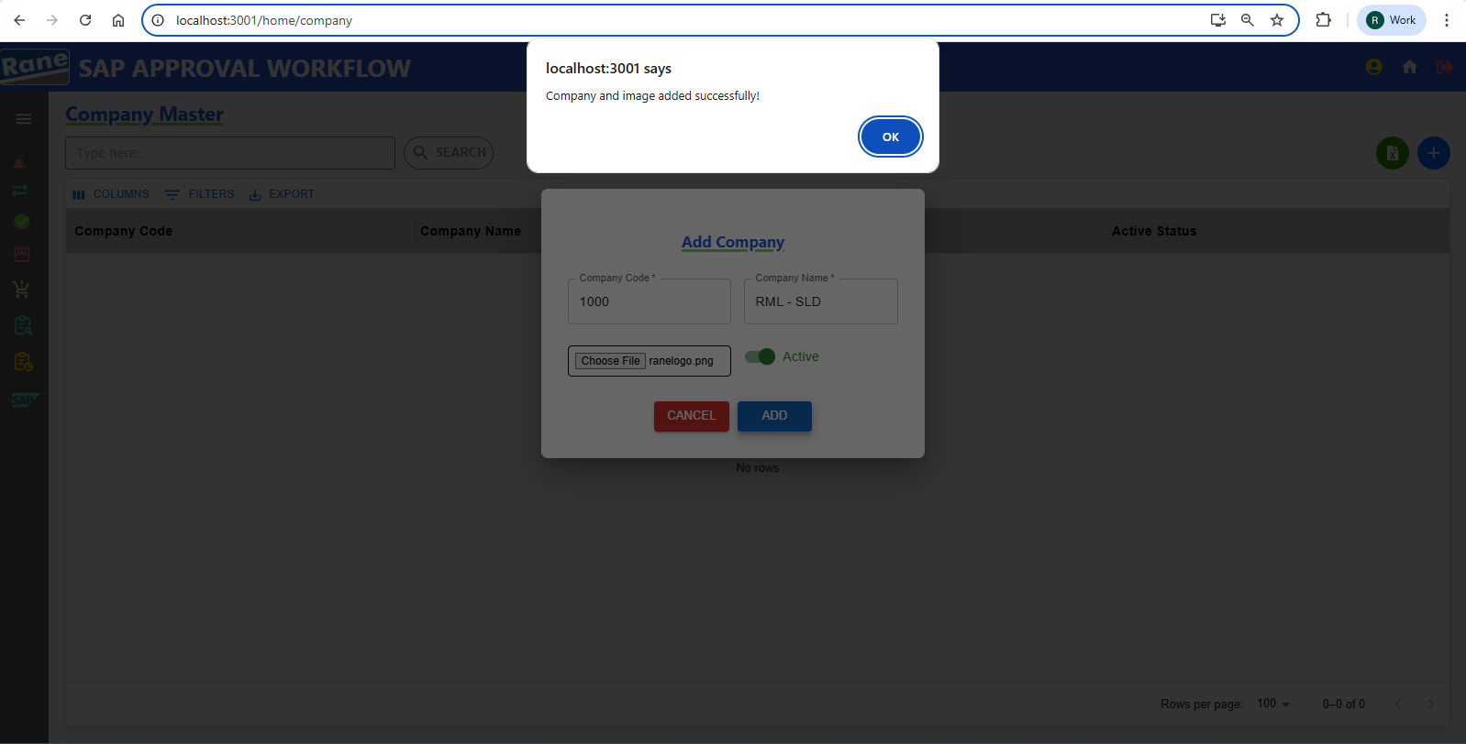

2. Update **Company Name** and **Active Status**  PASS

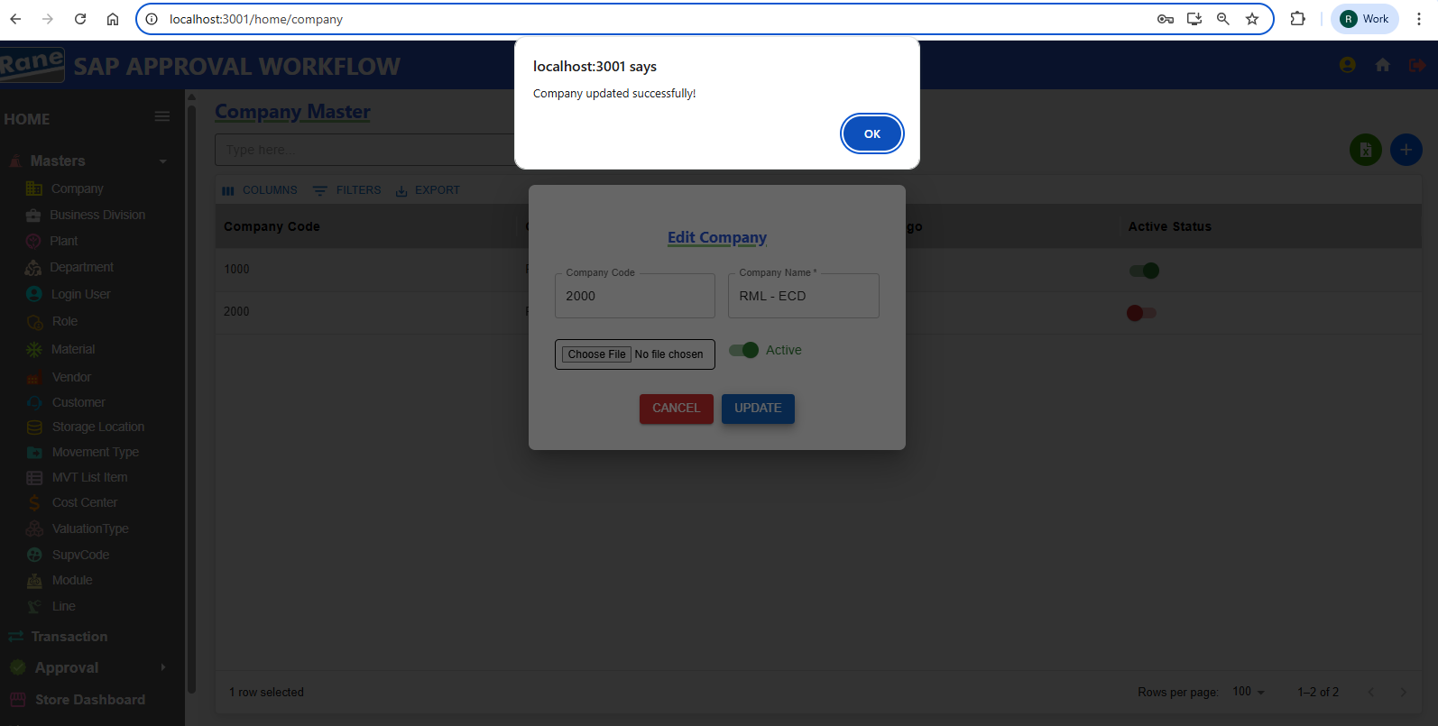

### Company Code - Disabled **(Read-Only)** PASS

### Company Name - **Editable** PASS

Company Logo - **Editable** PASS

If the user needs to change the Company Logo , they must choose a file and update it.

Otherwise, for any other updates, changing the Company Logo is not required.

Update Active Status - **Editable** PASS

### **Business Decision**

### **Creation / Updation**

Test case - 2 :

1.**Business Division Code** Unique and (Not Allowing Duplicate) PASS

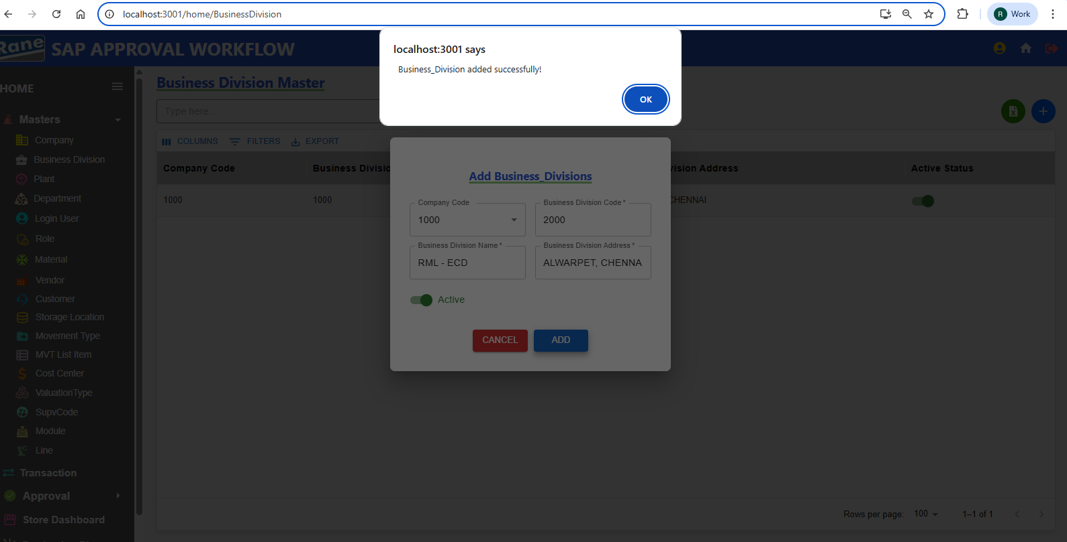

2.**Business Division Code -** Each Business Division Code must be unique within its associated Company Code. If a code already exists under the same Company Code, duplicate INSERTION IS NOT ALLOWED. PASS

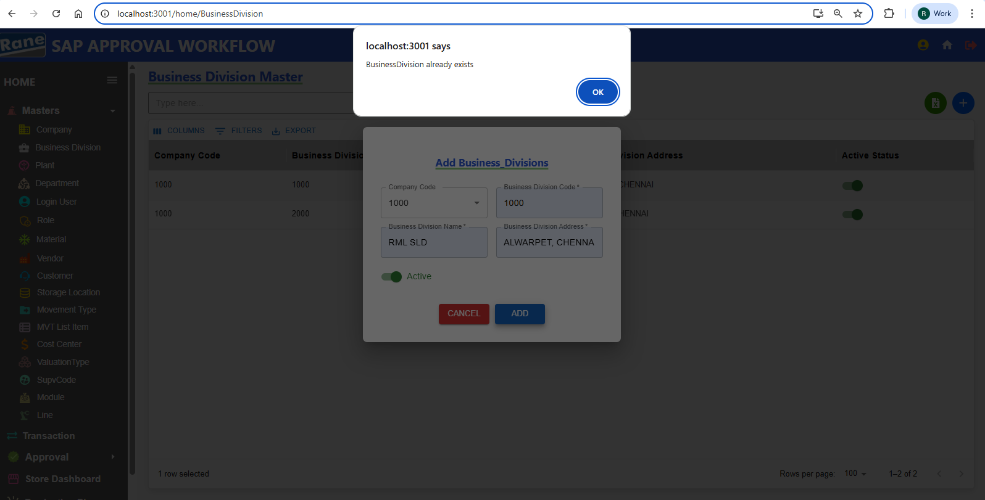

2. Update **Business Division Address** and **Active Status**  PASS

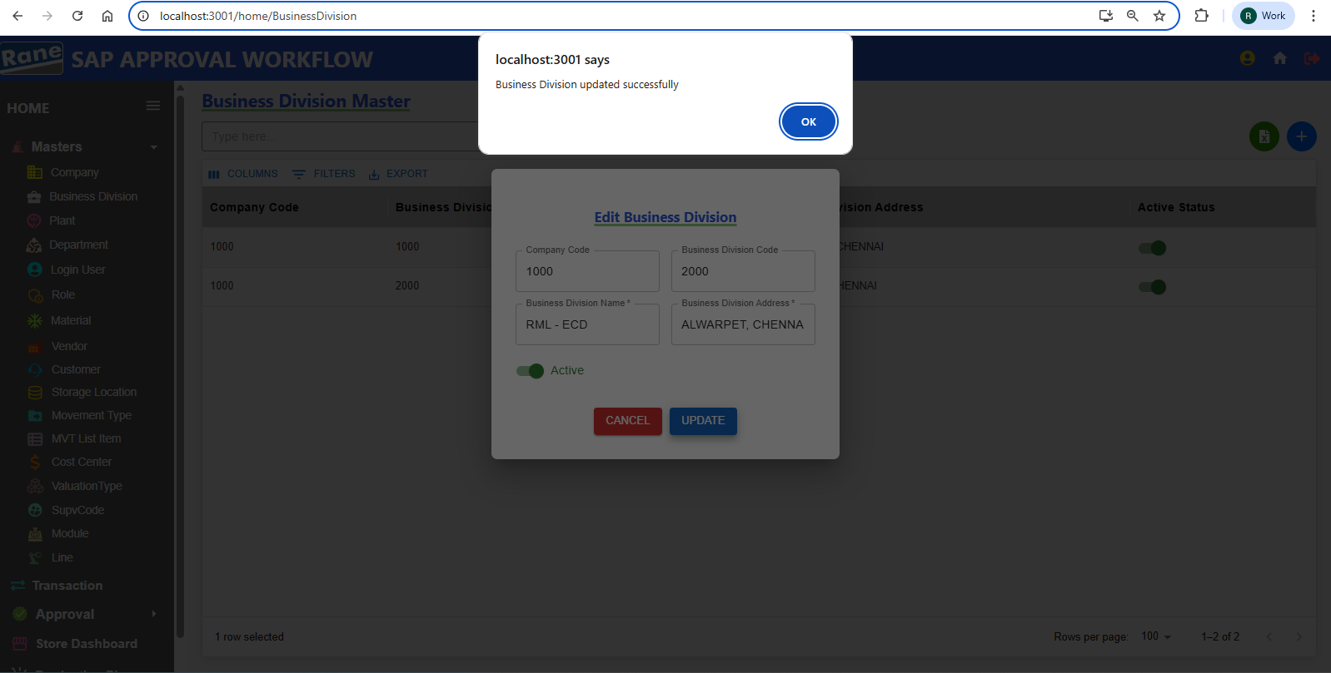

Company code - Disabled **(Read-Only)** PASS

Business Division Code - Disabled **(Read-Only)** PASS

Update Business Division Address - **Editable** PASS

Update Active Status - **Editable** PASS

**Plant**

### **Creation / Updation**

Test case - 3 :

1. **Plant Code** Unique(Not Allowing Duplicate) PASS

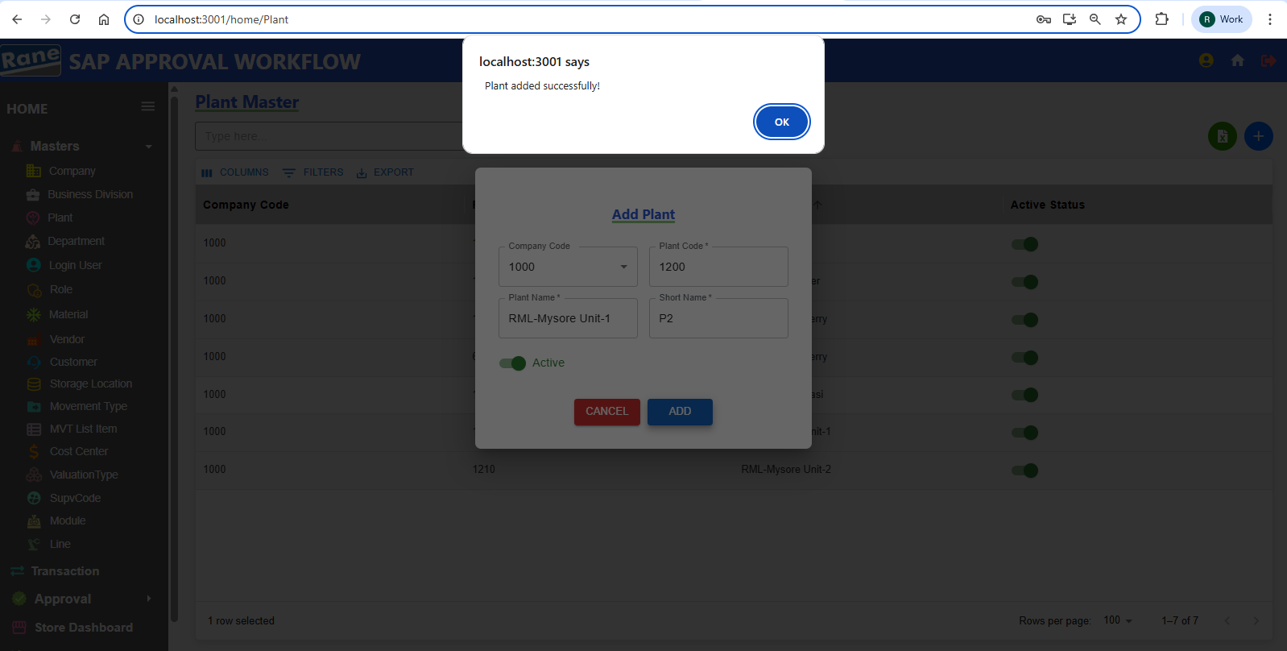

1. **Plant Code** If the same Plant Code already exists for the selected Company, INSERTION IS NOT ALLOWED. PASS

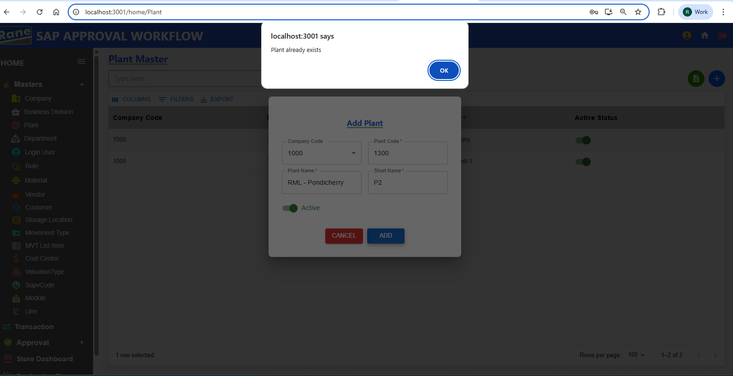

1. Update **Plant Name** and **Short_Name** PASS

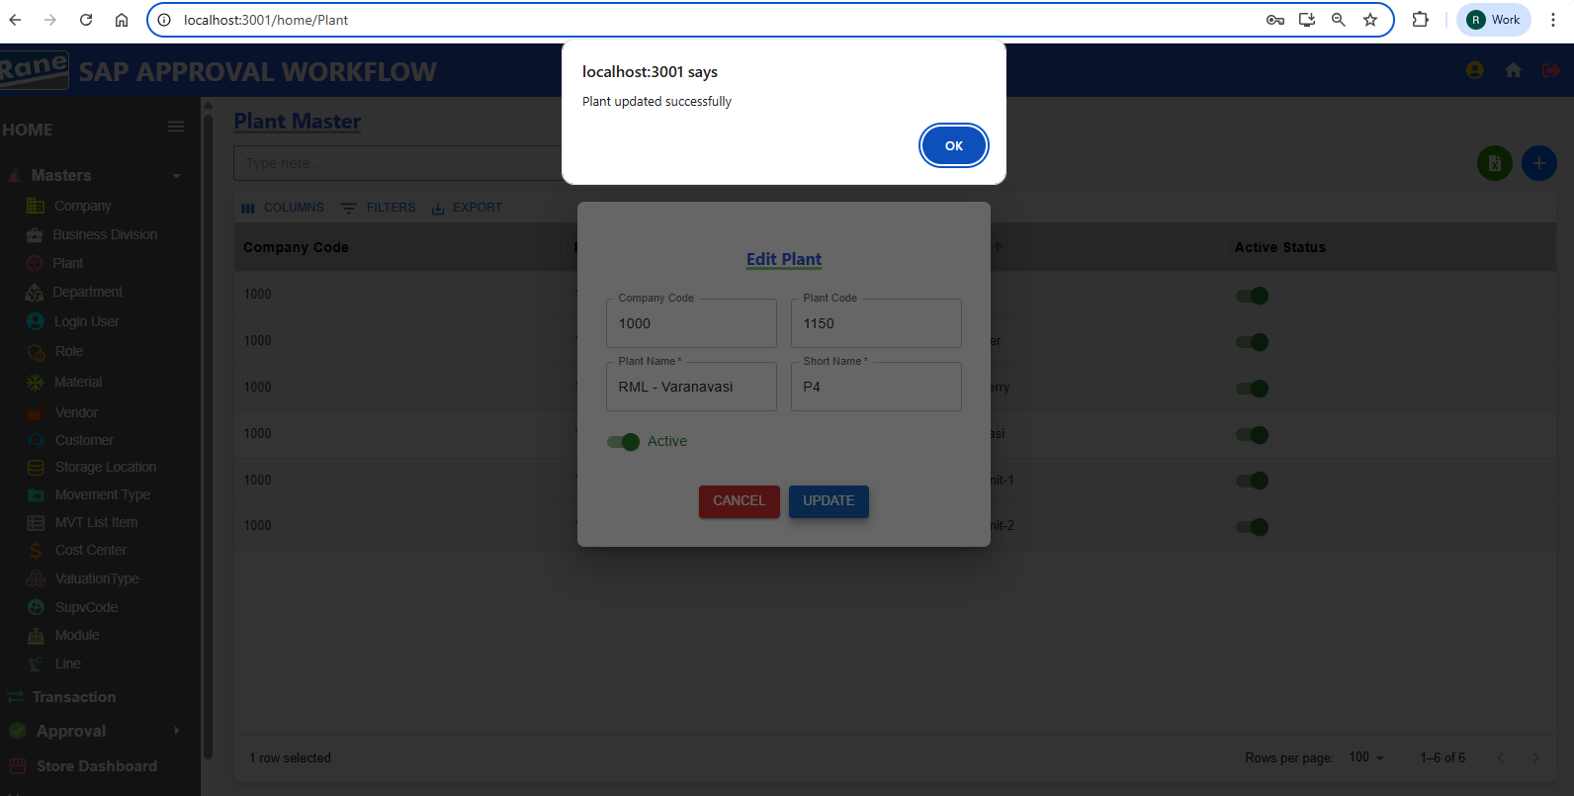

Company code - Disabled **(Read-Only)** PASS

Plant Code - Disabled **(Read-Only)** PASS

Update Plant Name - **Editable** PASS

Update Short Name - **Editable** PASS

Update Active Status - **Editable** PASS

**Department**

### **Creation / Updation**

Test case - 4 :

1. **Plant Code** Unique(Not Allowing Duplicate) PASS

Department code 3 digits ?????

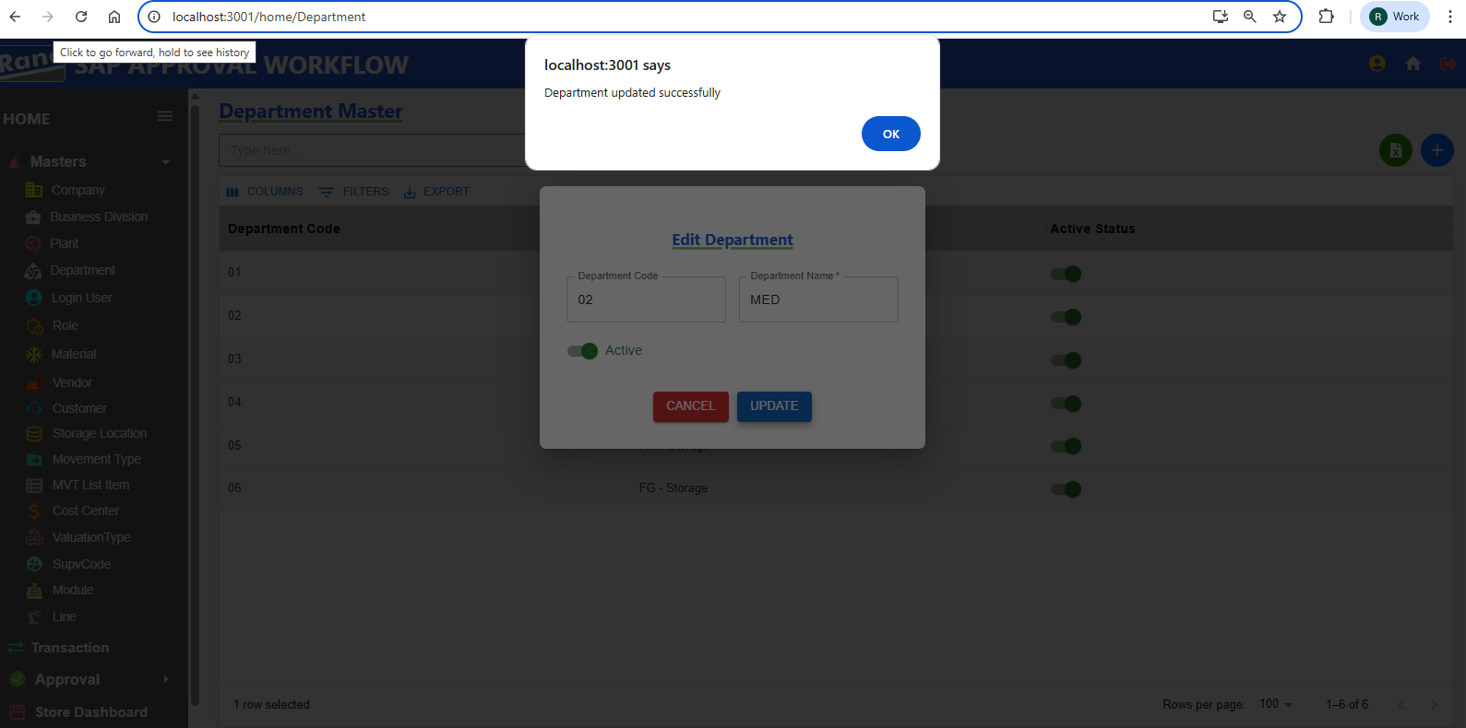

**User**

### **Creation / Updation**

Test case - 5 :

1. Employee ID Unique(Not Allowing Duplicate) PASS

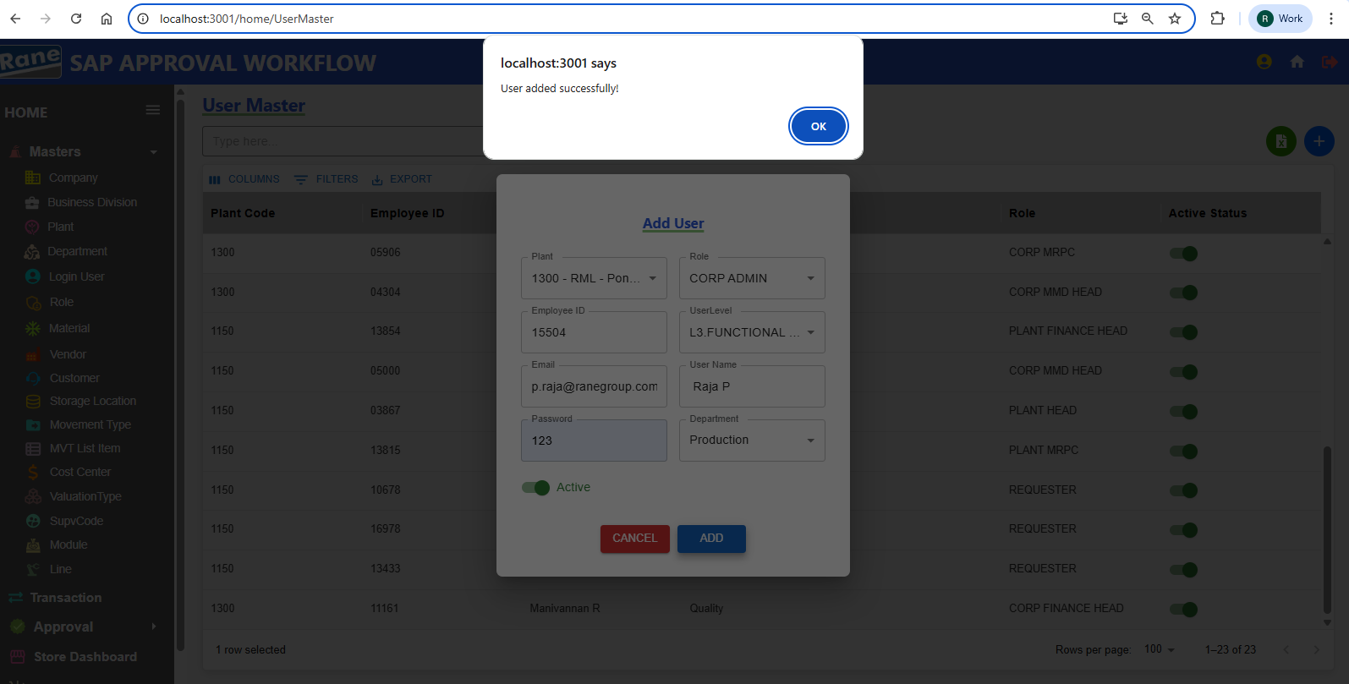

1. If The Employee ID Is Already Present In The User Master For The Selected Plant, New User INSERTION WILL NOT BE ALLOWED. PASS

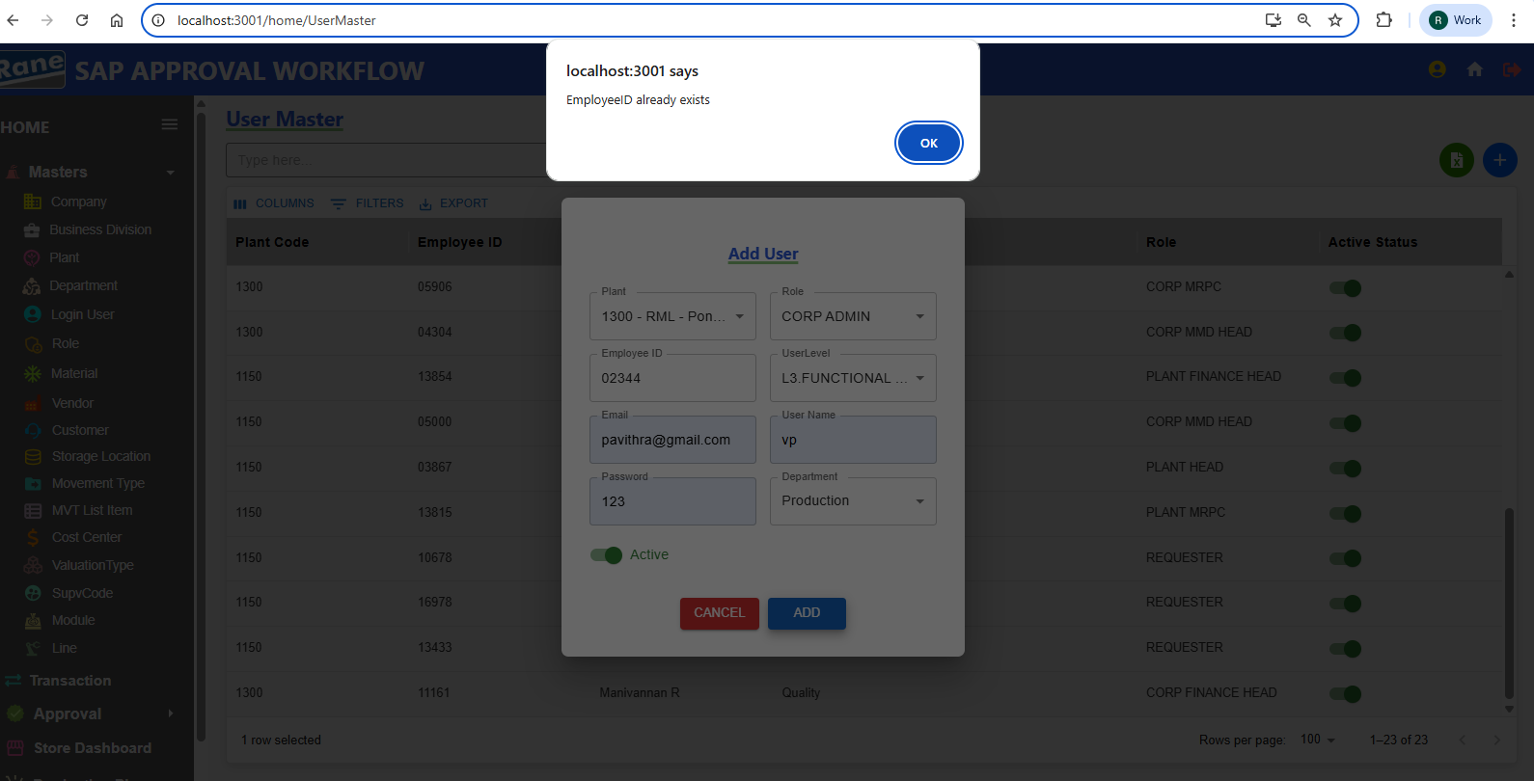

1. Update User Details PASS

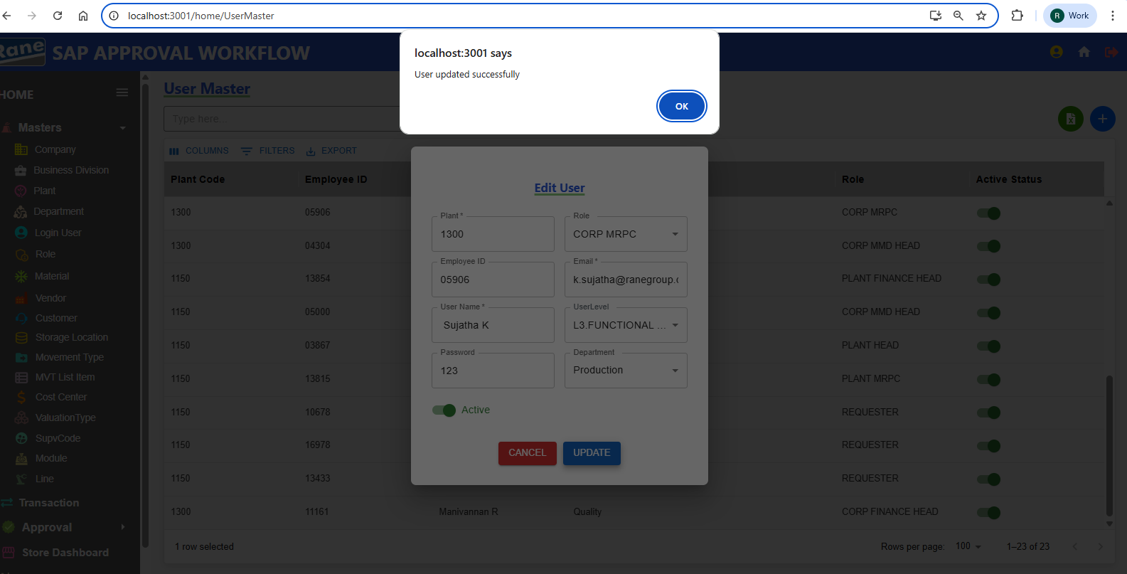

Plant code - Disabled **(Read-Only)** PASS

Employee - Disabled **(Read-Only)** PASS

Updation Role - **Editable** PASS

Updation Email - **Editable** PASS

Updation User Name - **Editable** PASS

Updation User Level - **Editable** PASS

Updation Password - **Editable** PASS

Updation Department - **Editable** PASS

Updation Active Status - **Editable** PASS

**Role**

### **Creation / Updation**

Test case - 6 :

1. Role – If the Role Name already exists in the Role Master, INSERTION IS NOT ALLOWED as it is a duplicate. Active status can be either true or false .PASS

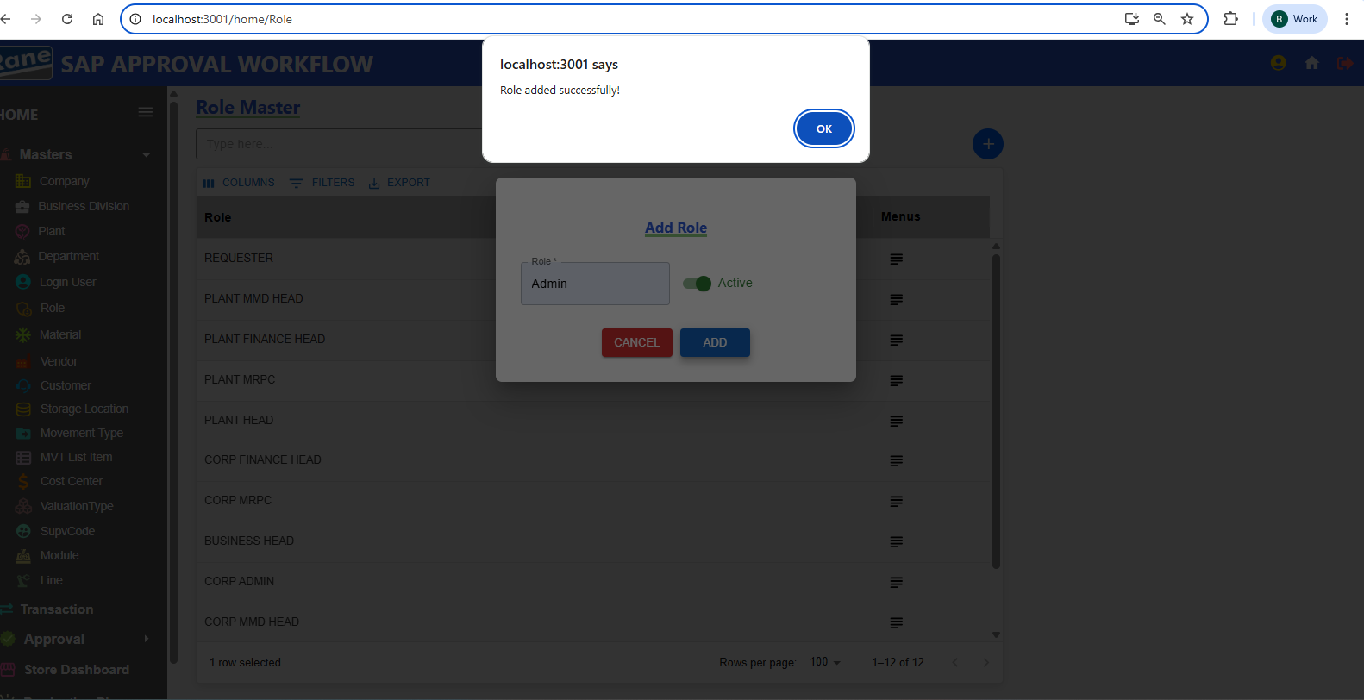

1. Updation Role Name and Active Status PASS

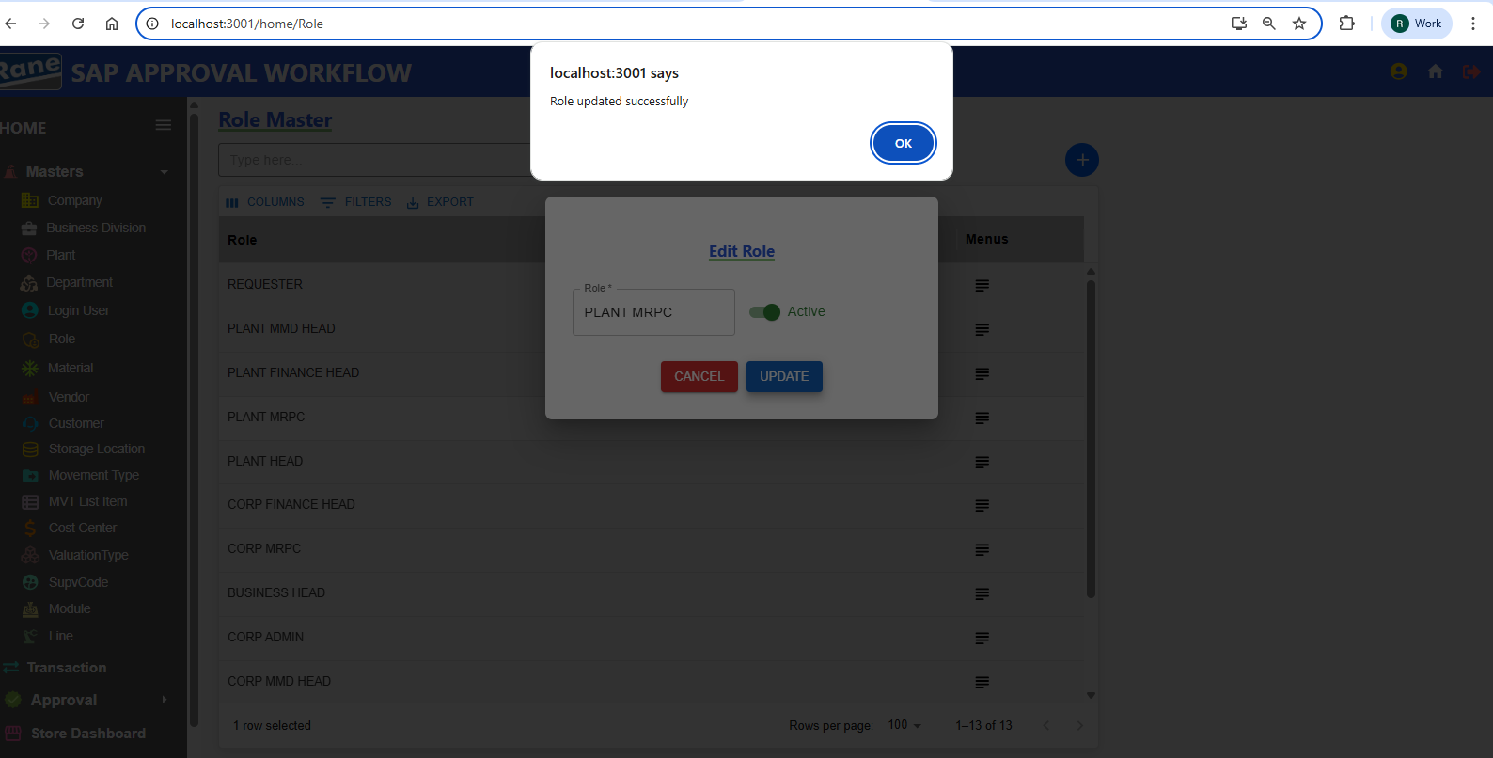

Updation Role - **Editable** PASS

Updation Active Status - **Editable** PASS

**Material**

### **Creation / Updation**

Test case - 7 : (Pending - Data)

**Vendor**

### **Creation / Updation**

Test case - 8 : (Pending - Data)

**Customer**

### **Creation / Updation**

Test case - 9 : (Pending - Data)

**Storage Location**

### **Creation / Updation**

Test case - 10 :

1. **Storage Code** Unique(Not Allowing Duplicate) PASS

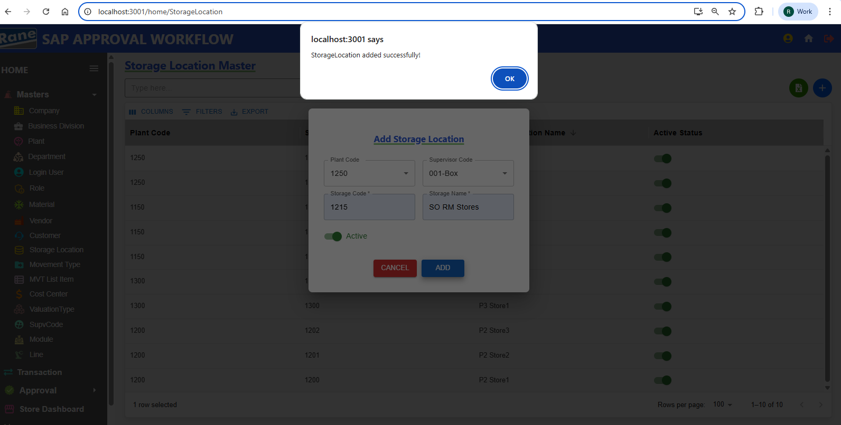

1. Storage Code Is Unique Based On The Plant. If The Storage Code Already Exists In The Selected Plant, INSERTION IS NOT ALLOWED As It Is A Duplicate.

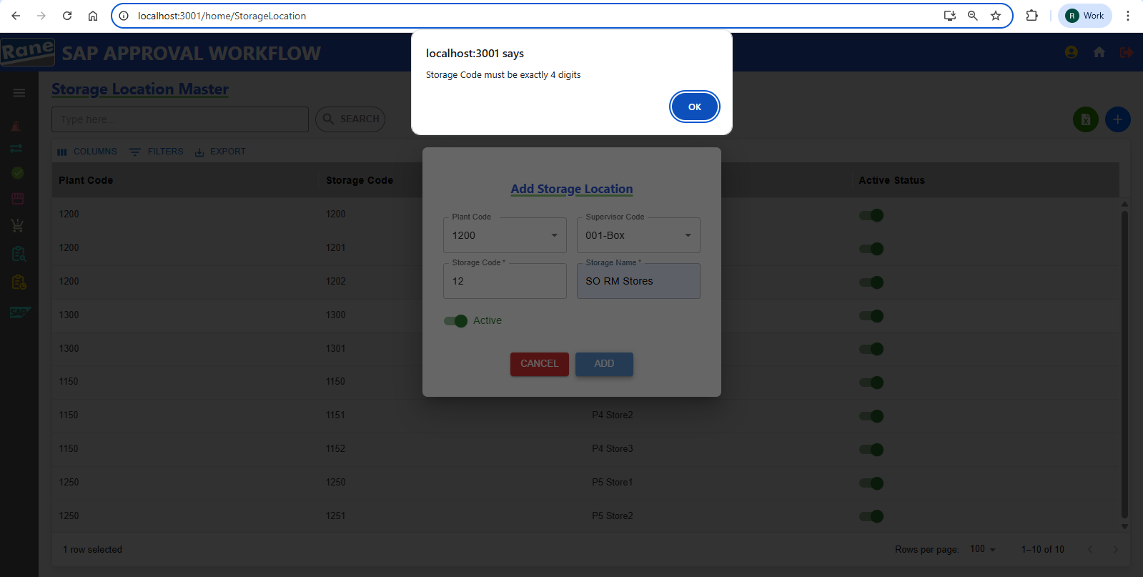

**Storage Code**  Must Be 4 Digits PASS

1. Update Storage Location PASS

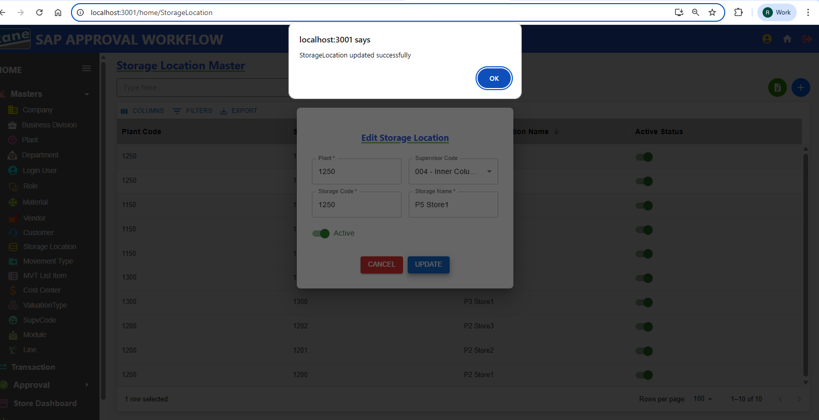

Storage code - Disabled **(Read-Only)** PASS

Plant Code - Disabled **(Read-Only)** PASS

Updation Storage Location Name - **Editable** PASS

Updation Supervisor Code - **Editable** PASS

Updation Active Status - **Editable** PASS

**Movement Type**

### **Creation / Updation**

Test case - 11 :

1. Movement Code Unique(Not Allowing Duplicate) PASS

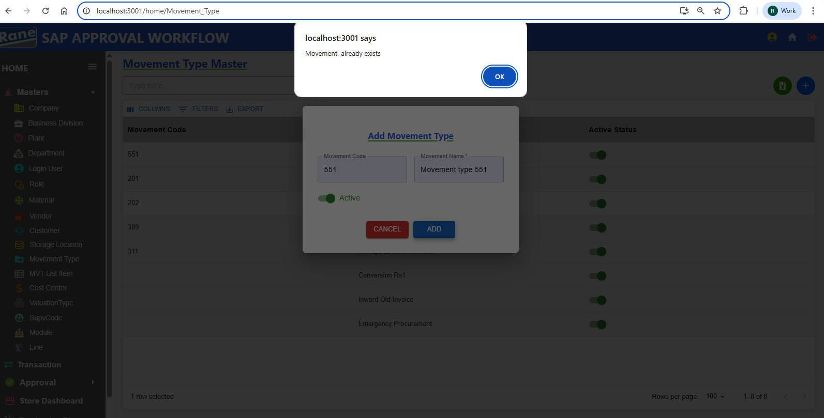

1. Update Movement Type PASS

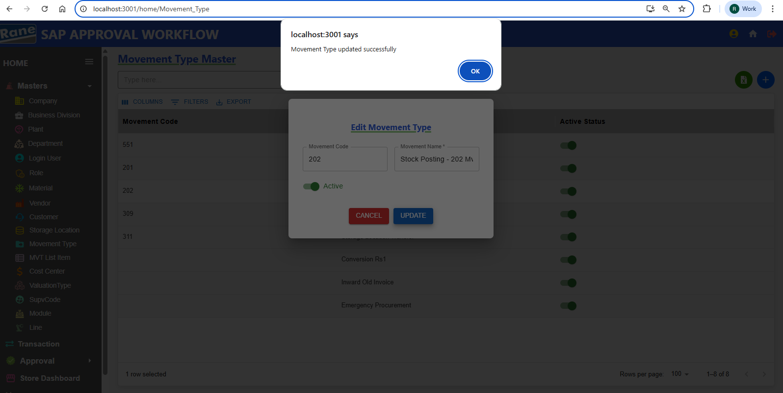

Movement Code - Disabled **(Read-Only)** PASS

Update Movement Name - **Editable** PASS

Updation Active Status - **Editable** PASS

**Movement List item**

### **Creation / Updation**

Test case - 12 :

**Cost Center**

### **Creation / Updation**

Test case - 12 : (Pending - Data)

**Valuation Type**

### **Creation / Updation**

Test case - 13 :

1. ValuationType Name Unique(Not Allowing Duplicate) PASS

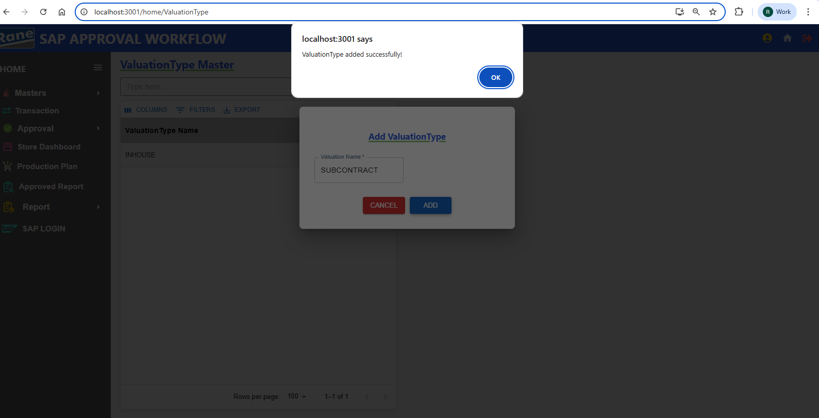

1. ValuationType Name Already Exists In The Valuation Master, INSERTION IS NOT ALLOWED As It Is A Duplicate. PASS

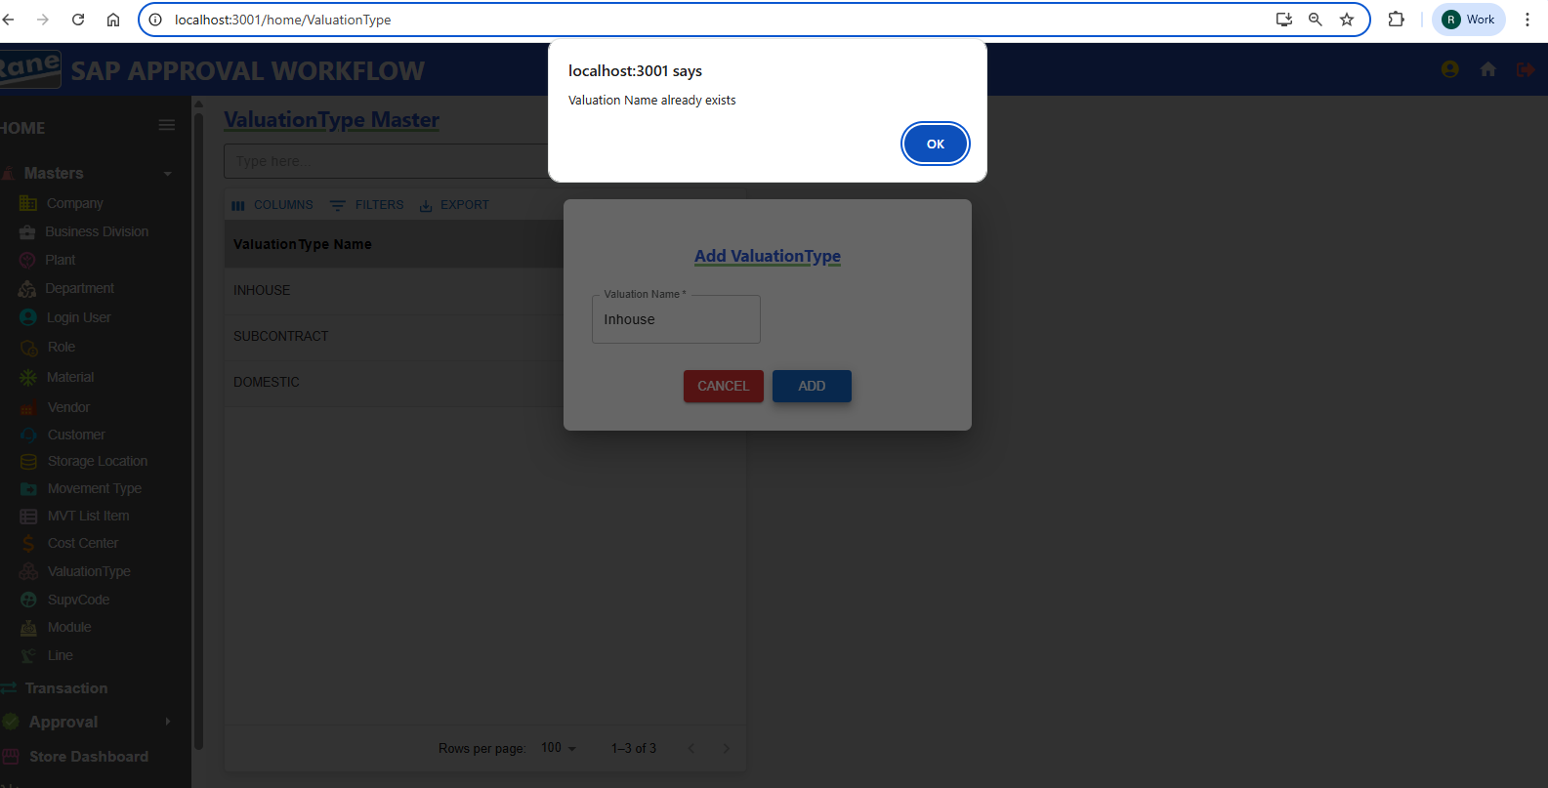

**Supervisor Code**

### **Creation / Updation**

Test case - 14 : (Pending - Data)

**Module**

### **Creation / Updation**

Test case - 15 :

1. Insert Name Based on ??????? Unique

2. Update **Module** PASS 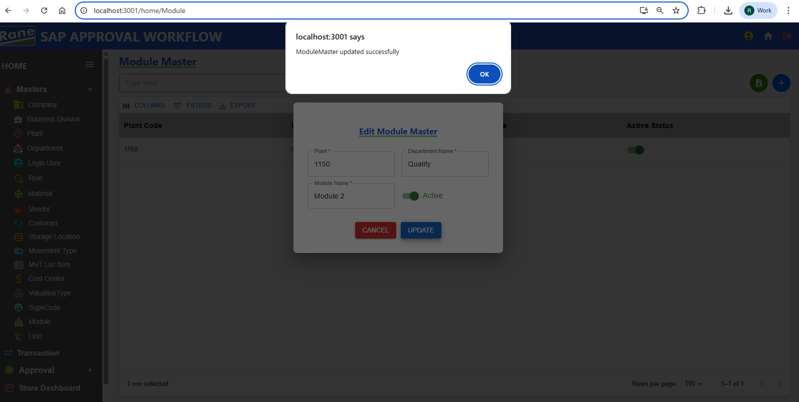

PlantCode - Disabled **(Read-Only)** PASS

Department Name - Disabled **(Read-Only)** PASS

Updation Module Name - **Editable** PASS

Updation Active Status - **Editable** PASS

**Line**

### **Creation / Updation**

Test case - 16 : (Pending - Data)

1. Create Insert Name Based on ??????? Unique
2. Update Line

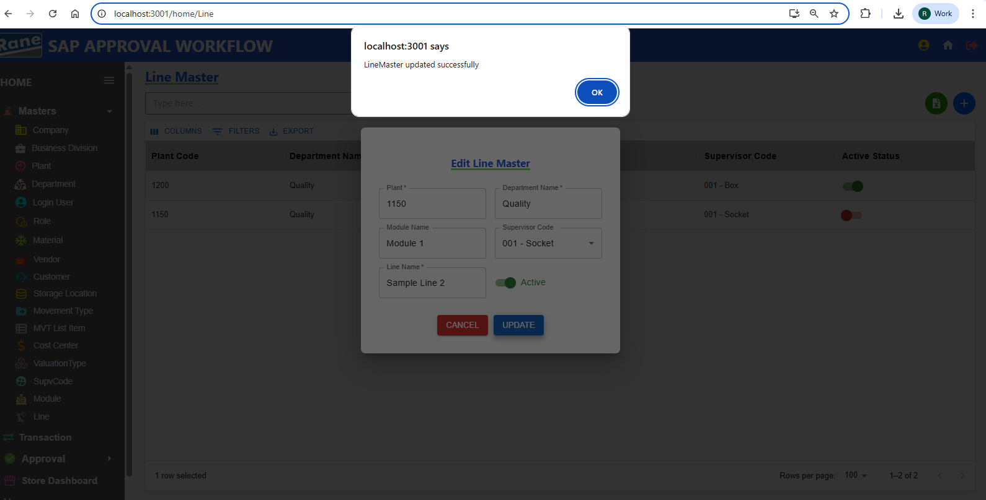

Plant Code- Disabled **(Read-Only)** PASS

Module Name - Disabled **(Read-Only)** PASS

Department Name - Disabled **(Read-Only)** PASS

Updation Supervisor Code- **Editable** PASS

Updation Line Name - **Editable** PASS

Updation Active Status - **Editable** PASS

**2.Transitions**

**309 Movement Transitions**

### **Creation / Updation**

**Test case - 1 :**

**201 Movement Transitions**

### **Creation / Updation**

**Test case - 2 :**

**202 Movement Transitions**

### **Creation / Updation**

**Test case - 3 :**

**551 Movement Transitions**

### **Creation / Updation**

**Test case - 4 :**

**311 Movement Transitions**

### **Creation / Updation**

**Test case - 5 :**

**Conversion Rs.1 Transitions**

### **Creation / Updation**

**Test case - 6 :**

**Inward Od Old Invoices**

### **Creation / Updation**

**Test case - 7 :**

**Emergency Procurement**

### **Creation / Updation**

**Test case - 8 :**

**____________________________________________________________**

### **Approval**

* 309 Approval
* 201 Approval
* 202 Approval
* 551 Approval
* 311 Approval
* Conversion Rs.1 Approval
* Inward Of Old Invoices Approval
* Emergency Procurement Approval